**Linux exercise 4 -Basic commands**

1. **What is the path for your home directory? How do you change your current working directory to your home directory?**

**a.**This is the home directory for user “jean”

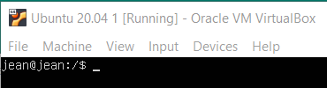

b. This is the overall home directory where we find home directories for different users

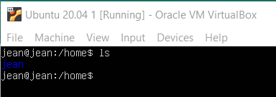c

The commands cd and cd ~ will switch from current directory to home directory.

1. **How can you find out your current working directory?**

With the command pwd

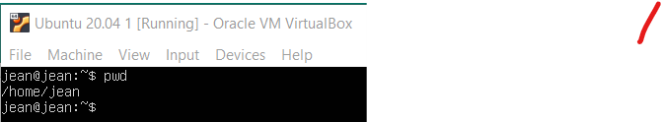

1. **Explain briefly what option -p does when used with mkdir command. In addition, find out what version number of mkdir command you have.**

**mkdir -p command can be used to create nested directories, that is if there are no parent directory it can create them too.**

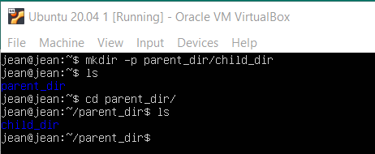

**You can find its version with mkdir –version command**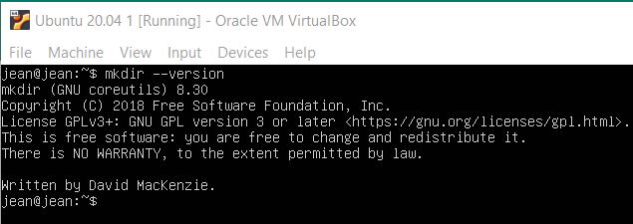

1. **Create the following directory structure including the files to your home directory using your Linux shell. Files can be empty or containing text.**

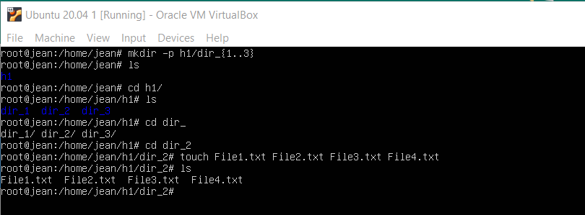

1. **Copy all files with .txt extension from dir2 to dir1 using relative path for directories using only one command.**

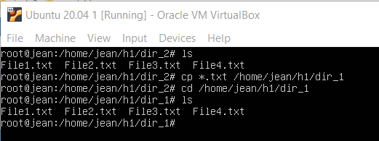

1. **Move all files starting with string File1 from dir2 to dir3 using absolute path for directories using only one command.**

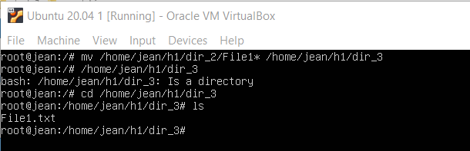

1. **Create tmp directory inside your home directory. Copy directory structure created in fourth part starting from directory h1 into the tmp directory in one command. The final directory tree should then look like this: /home/your_user/tmp/h1...**

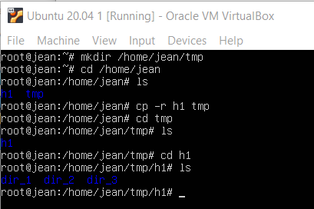

1. **Remove tmp/h1 directory structure from your home directory using only one command.**

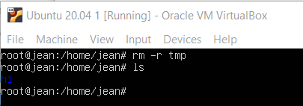

1. **Rename File1.txt file under dir1 in a way it begins with string NewFileX1 (File1.txt → NewFileX1.txt)**

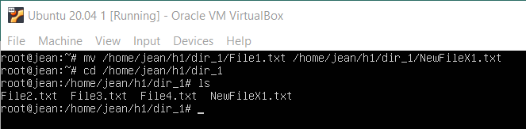

1. Absolute path is a full path to a file(folder) from the root directory (/)

Ex: /home/jean/h1/dir_1 is an absolute path to the directory dir_1

A relative path is a path that starts at the current directory and doesn’t start with /

Ex: Suppose your pwd is /home/jean/h1/ and you want to go to the directory dir_1. In this case you will just type cd dir_1. You will not need to type the whole absolute path.